Intermational Majorette Festival „GOLDEN HEART“-Petrinja/CROATIA
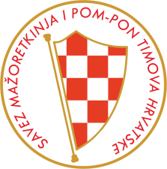
Sunday-19.03.2017.
A-BASIC REGISTRATION FORM
Deadline 01.03.2017.
___________________________________________________________________________
Form send by e-mail: majorettes.petrinja@gmail.com
majorettes.cro@gmail.com
COUNTRY: TOWN: CLUB:
Contact person: Mobil phone: E-mail:
Post adress: Data for invoice:

SOLO FORMATIONS and GROUPS-5,00 EUR –one competitor for every category

BATON/  POM-PON/  MIX/  BATONFLAG/  CLASSIC/  DRUMMERS/  MACE/  TWIRLING | KIDS  CAD  JUN  SEN  PAR | SOLO/  DUO-TRIO/  MINI F./  GROUP | Name majorettes for solo amd duo-trio  Name group or formation | Number  Person  X 5 Eur
 |  |  |  | X 5 EUR
 |  |  | TOTAL solo formations and groups:

SAVEZ MAŽORETKINJE I POM-PON TIMOVA HRVATSKE
Bank account: RBA-Raiffeisen ban Austria d.d. Zagreb
IBAN HR922 484 008 1101 900 360 RBA-Raiffeisen bank Austria d.d.
SWIFT: RZBHHR2X

